Perimeter

Definition
# Source: AI Source: Provided by: [Data Path: Persons Table -> ID Column: 1, Name_En Column: Motasem Essam] -> From: [ChatGPT] on [7/17/2026]
Perimeter is the total distance around the outer boundary of a two-dimensional (2D) geometric figure. It is obtained by adding the lengths of all the sides of the figure.
Perimeter measures the boundary length, not the area enclosed by the figure.

Characteristics
# Source: AI Source: Provided by: [Data Path: Persons Table -> ID Column: 1, Name_En Column: Motasem Essam] -> From: [ChatGPT] on [7/17/2026]
Perimeter:
- Measures the distance around a closed figure.
- Applies only to two-dimensional shapes.
- Is expressed as a linear measurement.
- Depends on the lengths of the figure's sides.
- Is commonly measured in metric or imperial units.

Illustration
# Source: AI Source: Provided by: [Data Path: Persons Table -> ID Column: 1, Name_En Column: Motasem Essam] -> From: [ChatGPT] on [7/17/2026]
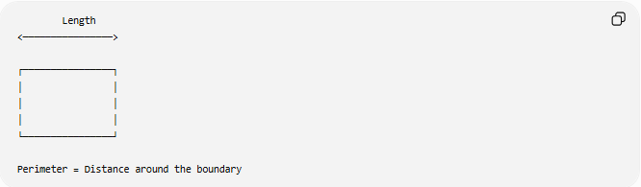
Length
<────────────────>

┌────────────────┐
│ │
│ │
│ │
└────────────────┘

Perimeter = Distance around the boundary

Measurement Units
# Source: AI Source: Provided by: [Data Path: Persons Table -> ID Column: 1, Name_En Column: Motasem Essam] -> From: [ChatGPT] on [7/17/2026]
Perimeter may be measured using:
Metric Units
- Millimeter (mm)
- Centimeter (cm)
- Meter (m)
- Kilometer (km)
Imperial Units
- Inch (in)
- Foot (ft)
- Yard (yd)
- Mile (mi)

Measuring Instruments
# Source: AI Source: Provided by: [Data Path: Persons Table -> ID Column: 1, Name_En Column: Motasem Essam] -> From: [ChatGPT] on [7/17/2026]
Common instruments used to measure perimeter include:
- Ruler
- Measuring Tape
- Flexible Tape Measure
- Surveyor's Wheel
- Laser Distance Meter
- CAD (Computer-Aided Design) software

Mathematical Representation
# Source: AI Source: Provided by: [Data Path: Persons Table -> ID Column: 1, Name_En Column: Motasem Essam] -> From: [ChatGPT] on [7/17/2026]
Perimeter is commonly represented by:
$$P$$

Perimeter Formulas
# Source: AI Source: Provided by: [Data Path: Persons Table -> ID Column: 1, Name_En Column: Motasem Essam] -> From: [ChatGPT] on [7/17/2026]
Square
$$P=4s$$
where:
- $s$= side length

Rectangle
$$P=2\left(l+w\right)$$
where:
- $l$= length
- $w$= width

Triangle
$$P=a+b+c$$
where:
- $a,b,c$= side lengths

Circle (Circumference)
The perimeter of a circle is called its circumference:
$$C=2πr$$
or
$$C=πd$$
where:
- $r$= radius
- $d$= diameter

Regular Polygon
$$P=n×s$$
where:
- $n$= number of sides
- $s$= side length

Examples
# Source: AI Source: Provided by: [Data Path: Persons Table -> ID Column: 1, Name_En Column: Motasem Essam] -> From: [ChatGPT] on [7/17/2026]
Rectangle
Length = 10 cm
Width = 6 cm
$$P=2\left(10+6\right)=32\text{ cm}$$

Square
Side = 8 cm
$$P=4×8=32\text{ cm}$$

Applications
# Source: AI Source: Provided by: [Data Path: Persons Table -> ID Column: 1, Name_En Column: Motasem Essam] -> From: [ChatGPT] on [7/17/2026]
Perimeter measurement is used in:
- Geometry
- Architecture
- Construction
- Land Surveying
- Landscaping
- Fencing
- Manufacturing
- CAD (Computer-Aided Design)
- Interior Design
- Agriculture

Advantages
# Source: AI Source: Provided by: [Data Path: Persons Table -> ID Column: 1, Name_En Column: Motasem Essam] -> From: [ChatGPT] on [7/17/2026]
Measuring perimeter helps to:
- Determine boundary length.
- Estimate fencing requirements.
- Calculate material needed for borders.
- Support architectural planning.
- Verify geometric dimensions.

Limitations
# Source: AI Source: Provided by: [Data Path: Persons Table -> ID Column: 1, Name_En Column: Motasem Essam] -> From: [ChatGPT] on [7/17/2026]
Perimeter:
- Measures only the boundary, not the enclosed space.
- Does not describe the area or volume.
- May require approximation for irregular curves.

Difference Between Perimeter and Area
# Source: AI Source: Provided by: [Data Path: Persons Table -> ID Column: 1, Name_En Column: Motasem Essam] -> From: [ChatGPT] on [7/17/2026]
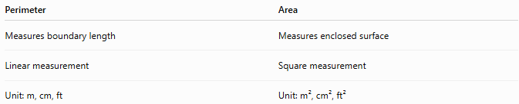
Perimeter | Area
Measures boundary length | Measures enclosed surface
Linear measurement | Square measurement
Unit: m, cm, ft | Unit: m², cm², ft²

Key Points
# Source: AI Source: Provided by: [Data Path: Persons Table -> ID Column: 1, Name_En Column: Motasem Essam] -> From: [ChatGPT] on [7/17/2026]
- Perimeter is the total distance around a closed two-dimensional figure.
- It is commonly represented by:
$$P$$
- Perimeter is measured in linear units.
- Different geometric figures have different perimeter formulas.
- Perimeter is widely used in geometry, construction, surveying, engineering, and design.

Conclusion
# Source: AI Source: Provided by: [Data Path: Persons Table -> ID Column: 1, Name_En Column: Motasem Essam] -> From: [ChatGPT] on [7/17/2026]
Perimeter is the measurement of the total length of the boundary surrounding a two-dimensional geometric figure. It is one of the most fundamental geometric measurements and is essential for determining boundary distances in mathematical calculations and real-world applications. Perimeter plays an important role in geometry, architecture, engineering, construction, surveying, landscaping, manufacturing, CAD, agriculture, and design, where accurate boundary measurement is necessary for planning, construction, and material estimation.

